Bitbucket and Azure Devops

Jayanth R

ACE11696

Im creating a workspace in bitbucket.

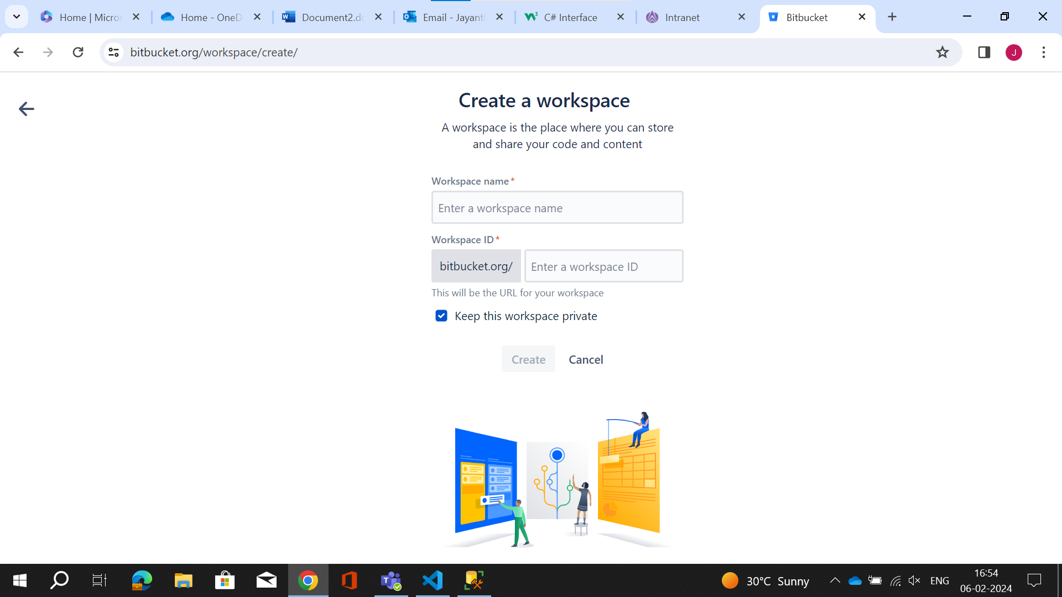

This is after i create a wrokspace.

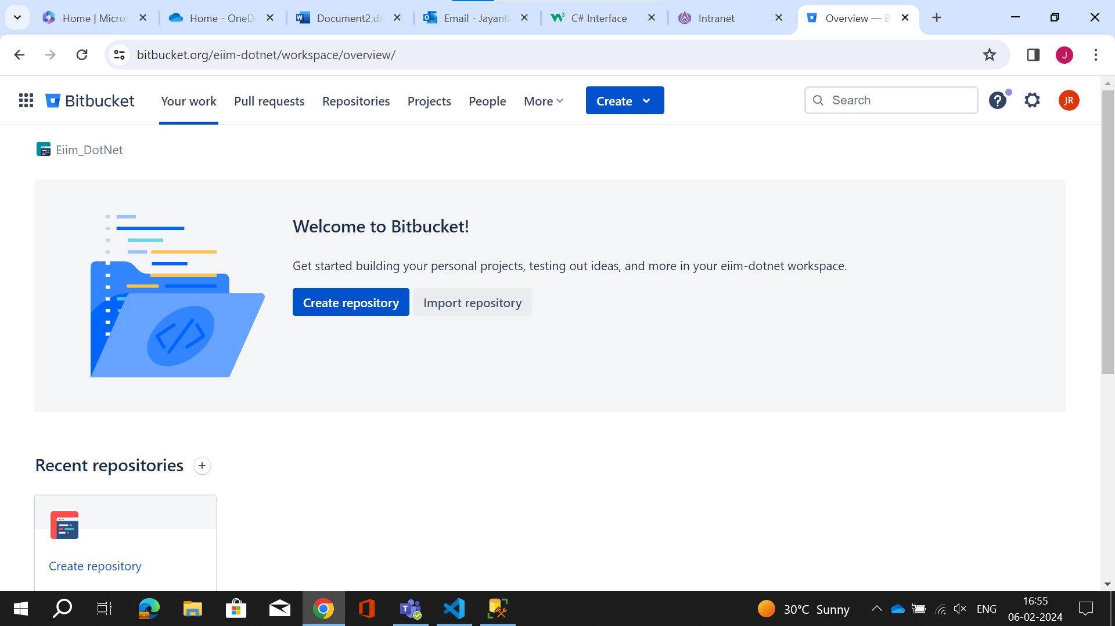

Next im creating a repository by giving project name and repository name.

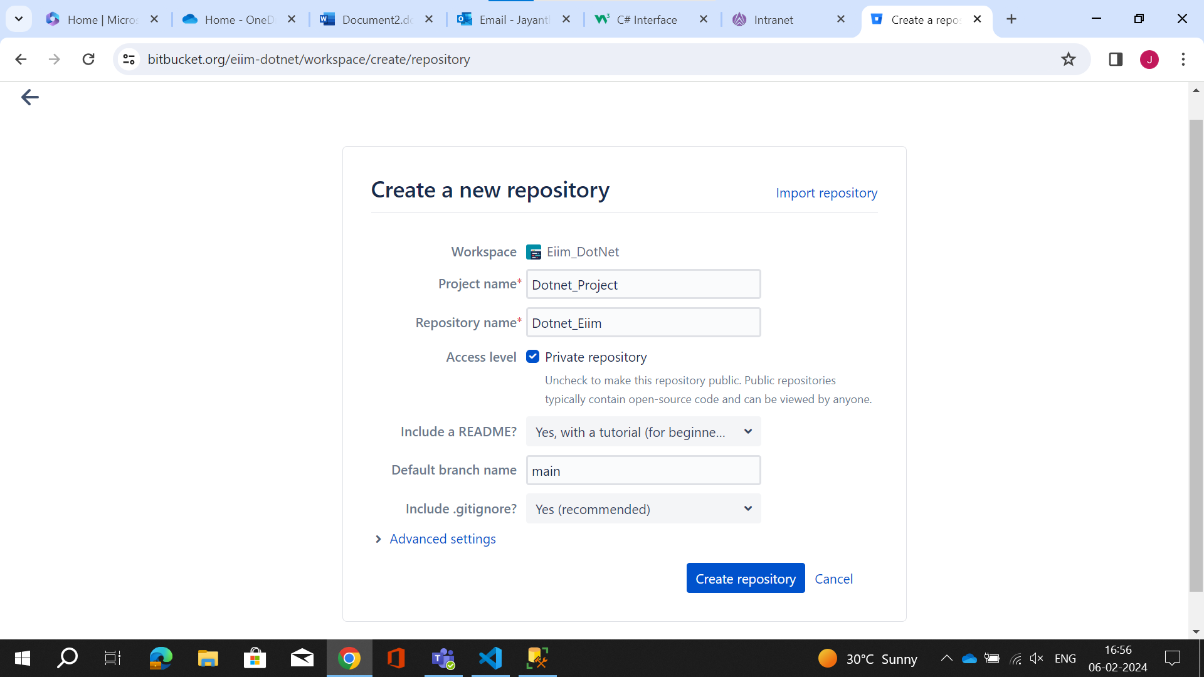

This is my repository that i have created and i must push my code here.

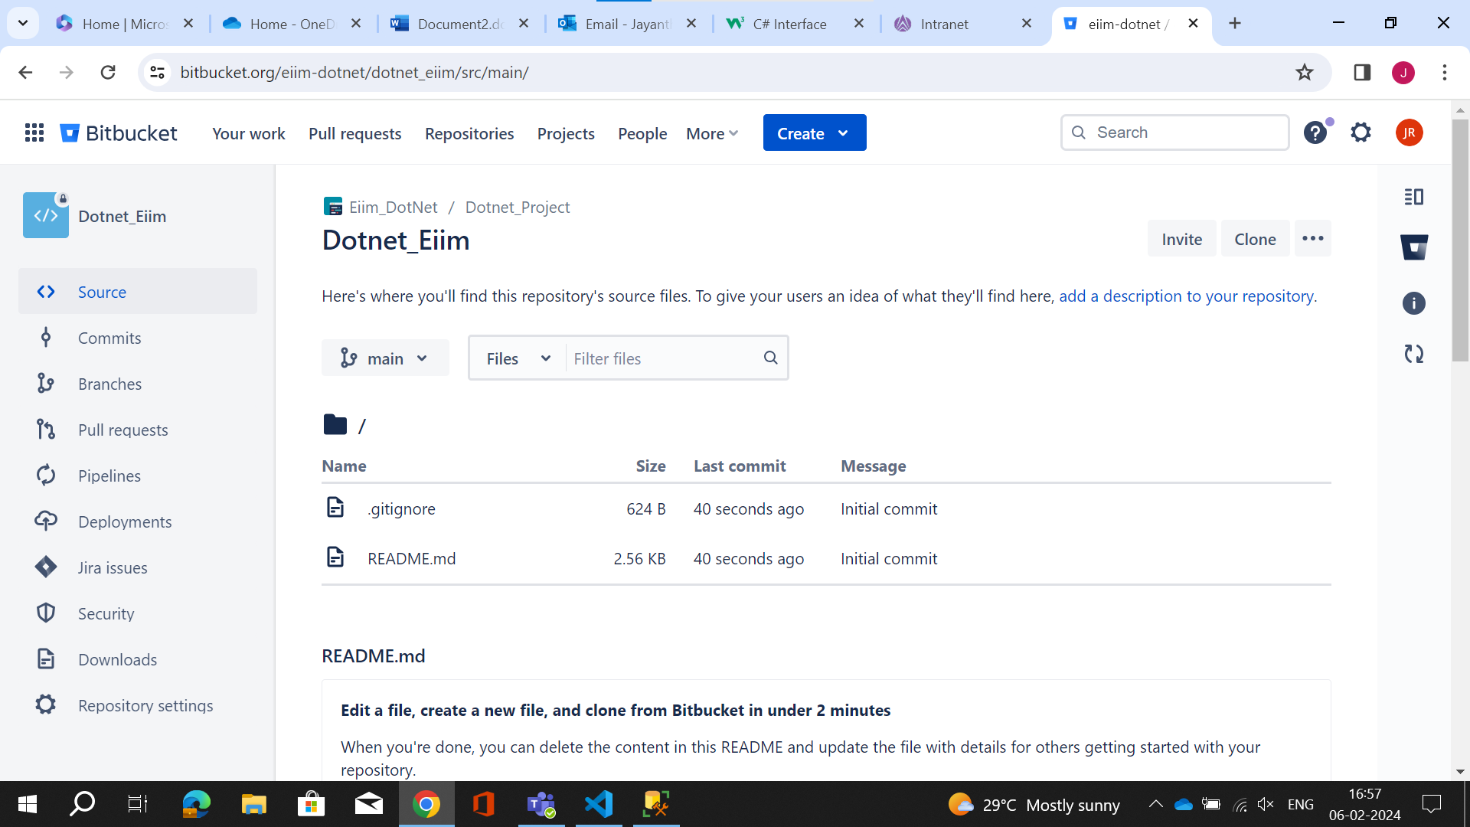

Before pushing i must configure my account.

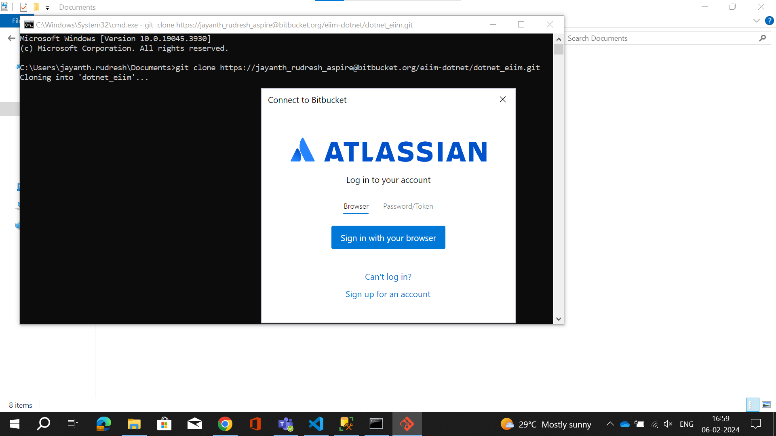

This is after the successful configuration which is authentication Successful.

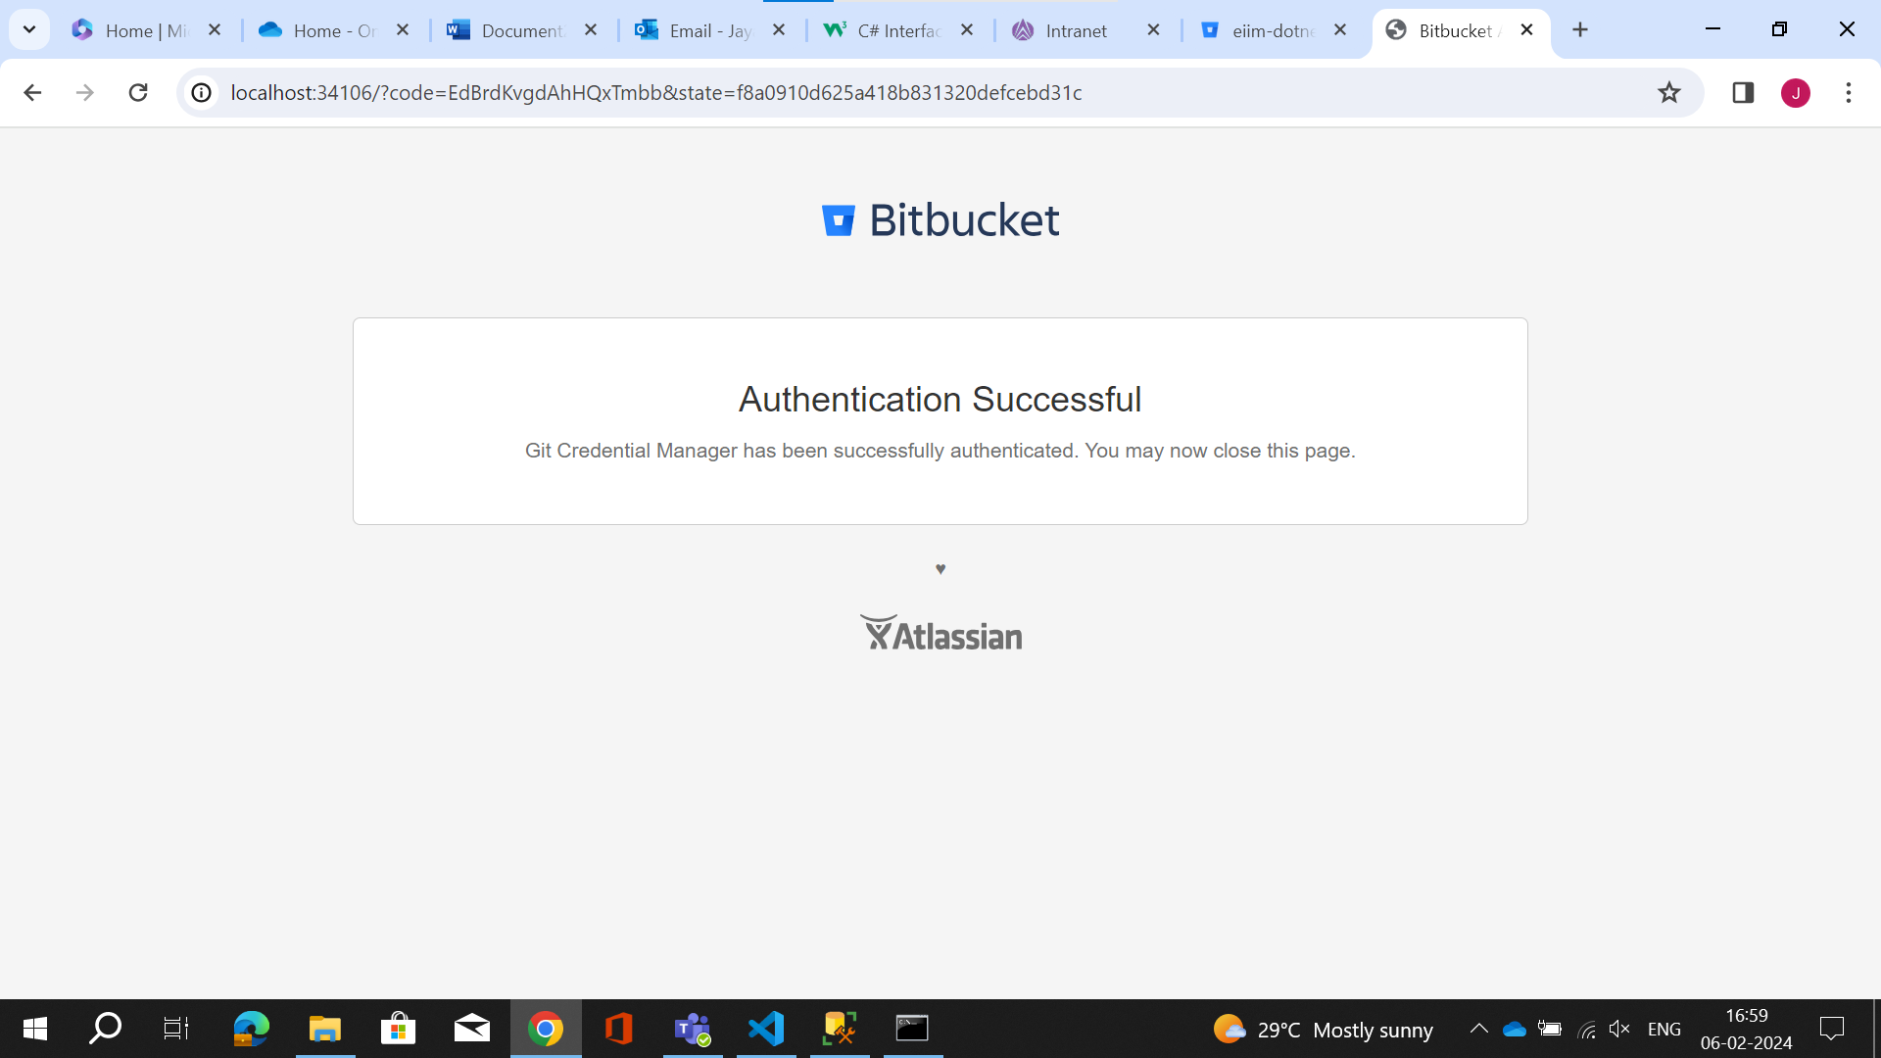

This is the procedure that im pushing the code using git.

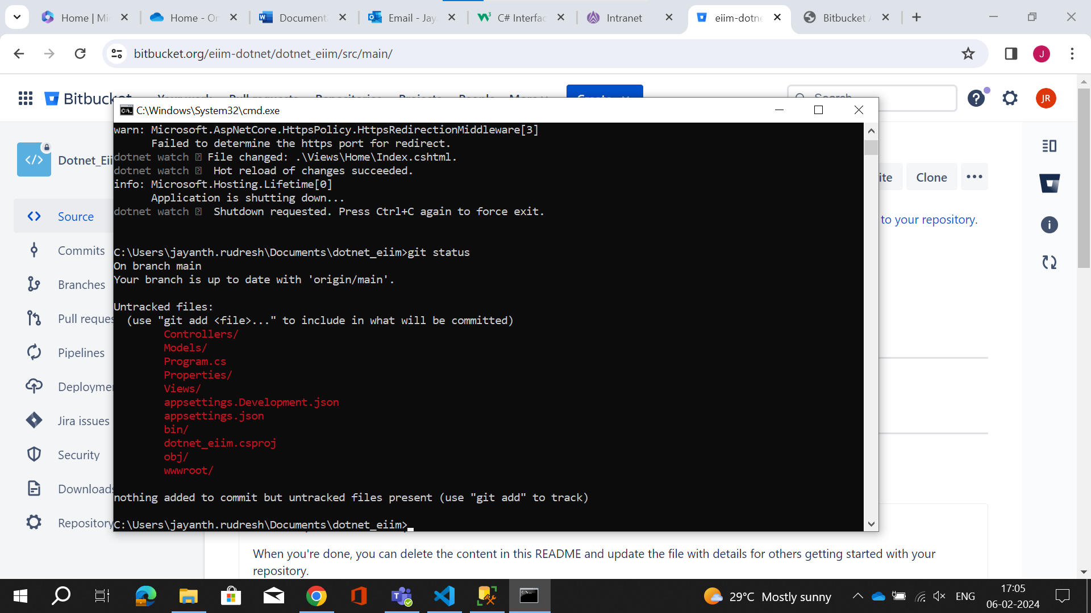

This is the procedure that im pushing the code using git.

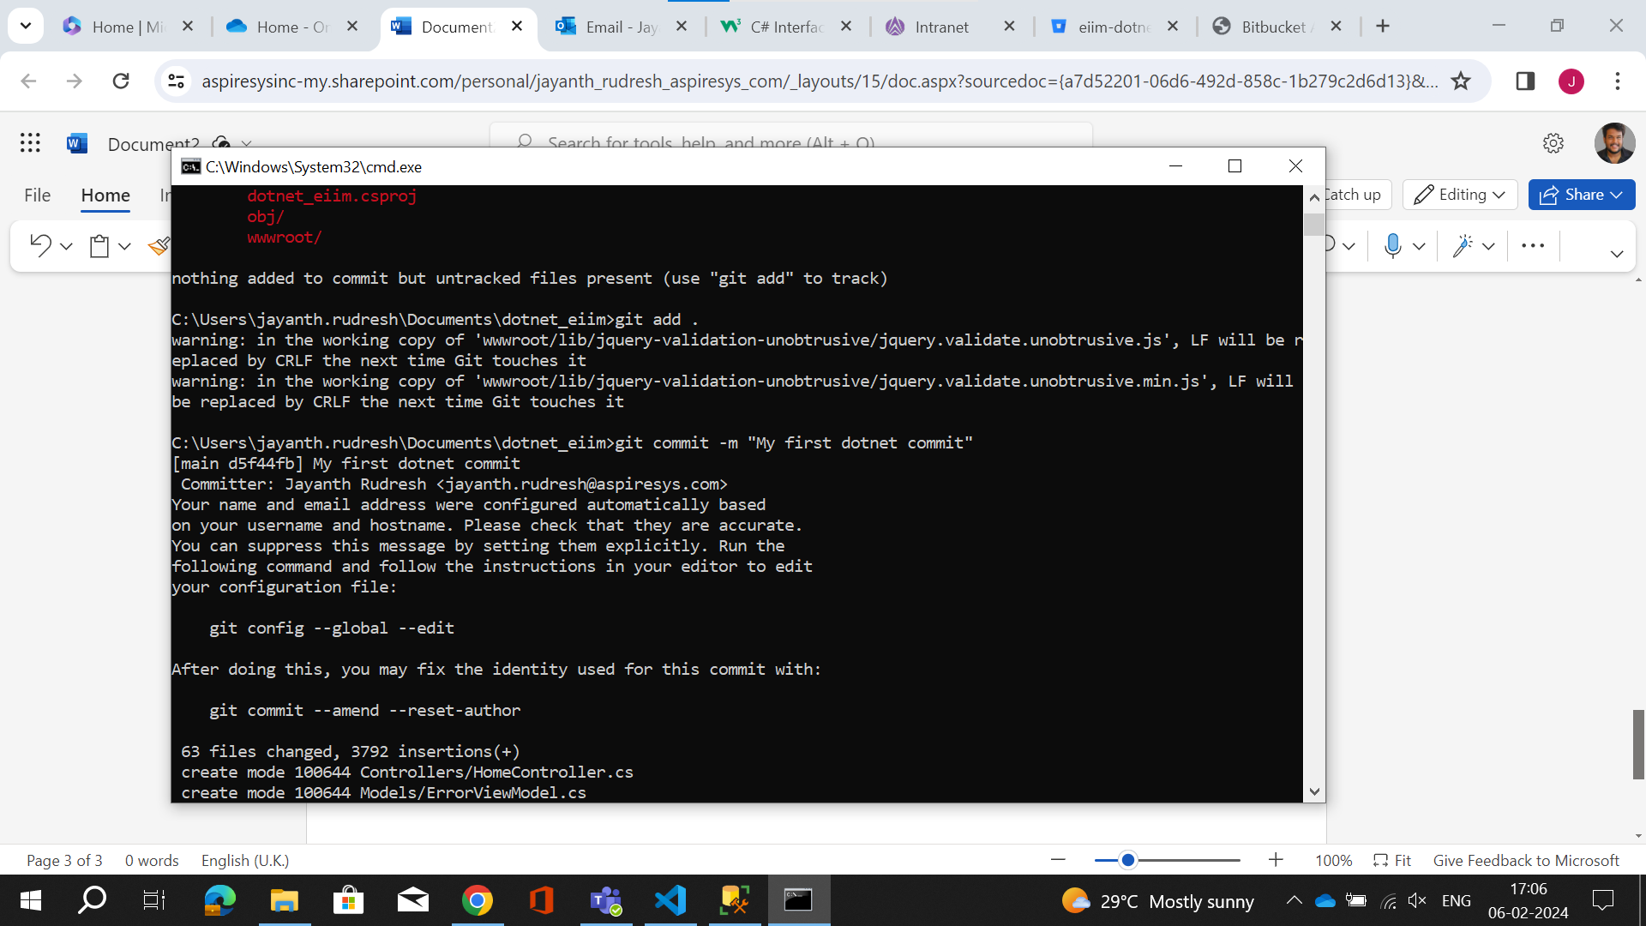

This is the procedure that im pushing the code using git.

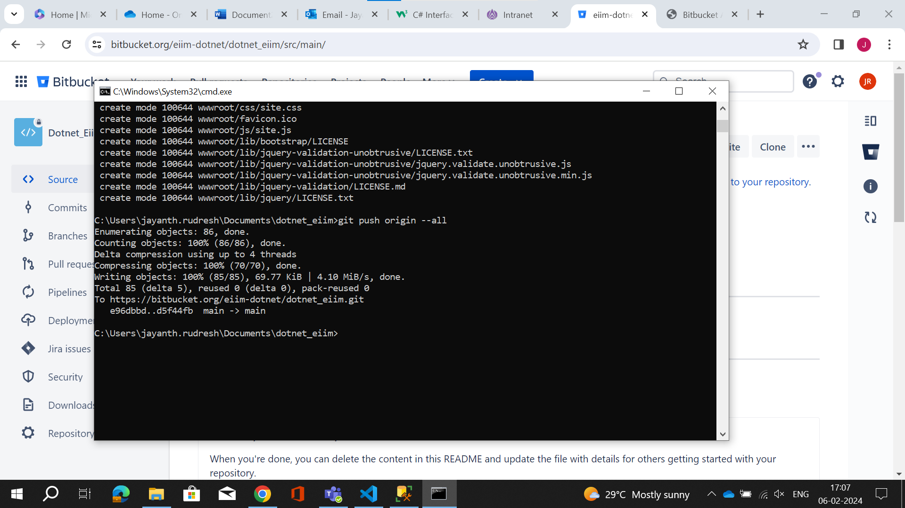

Here i have successfully push my code to bitbucket.

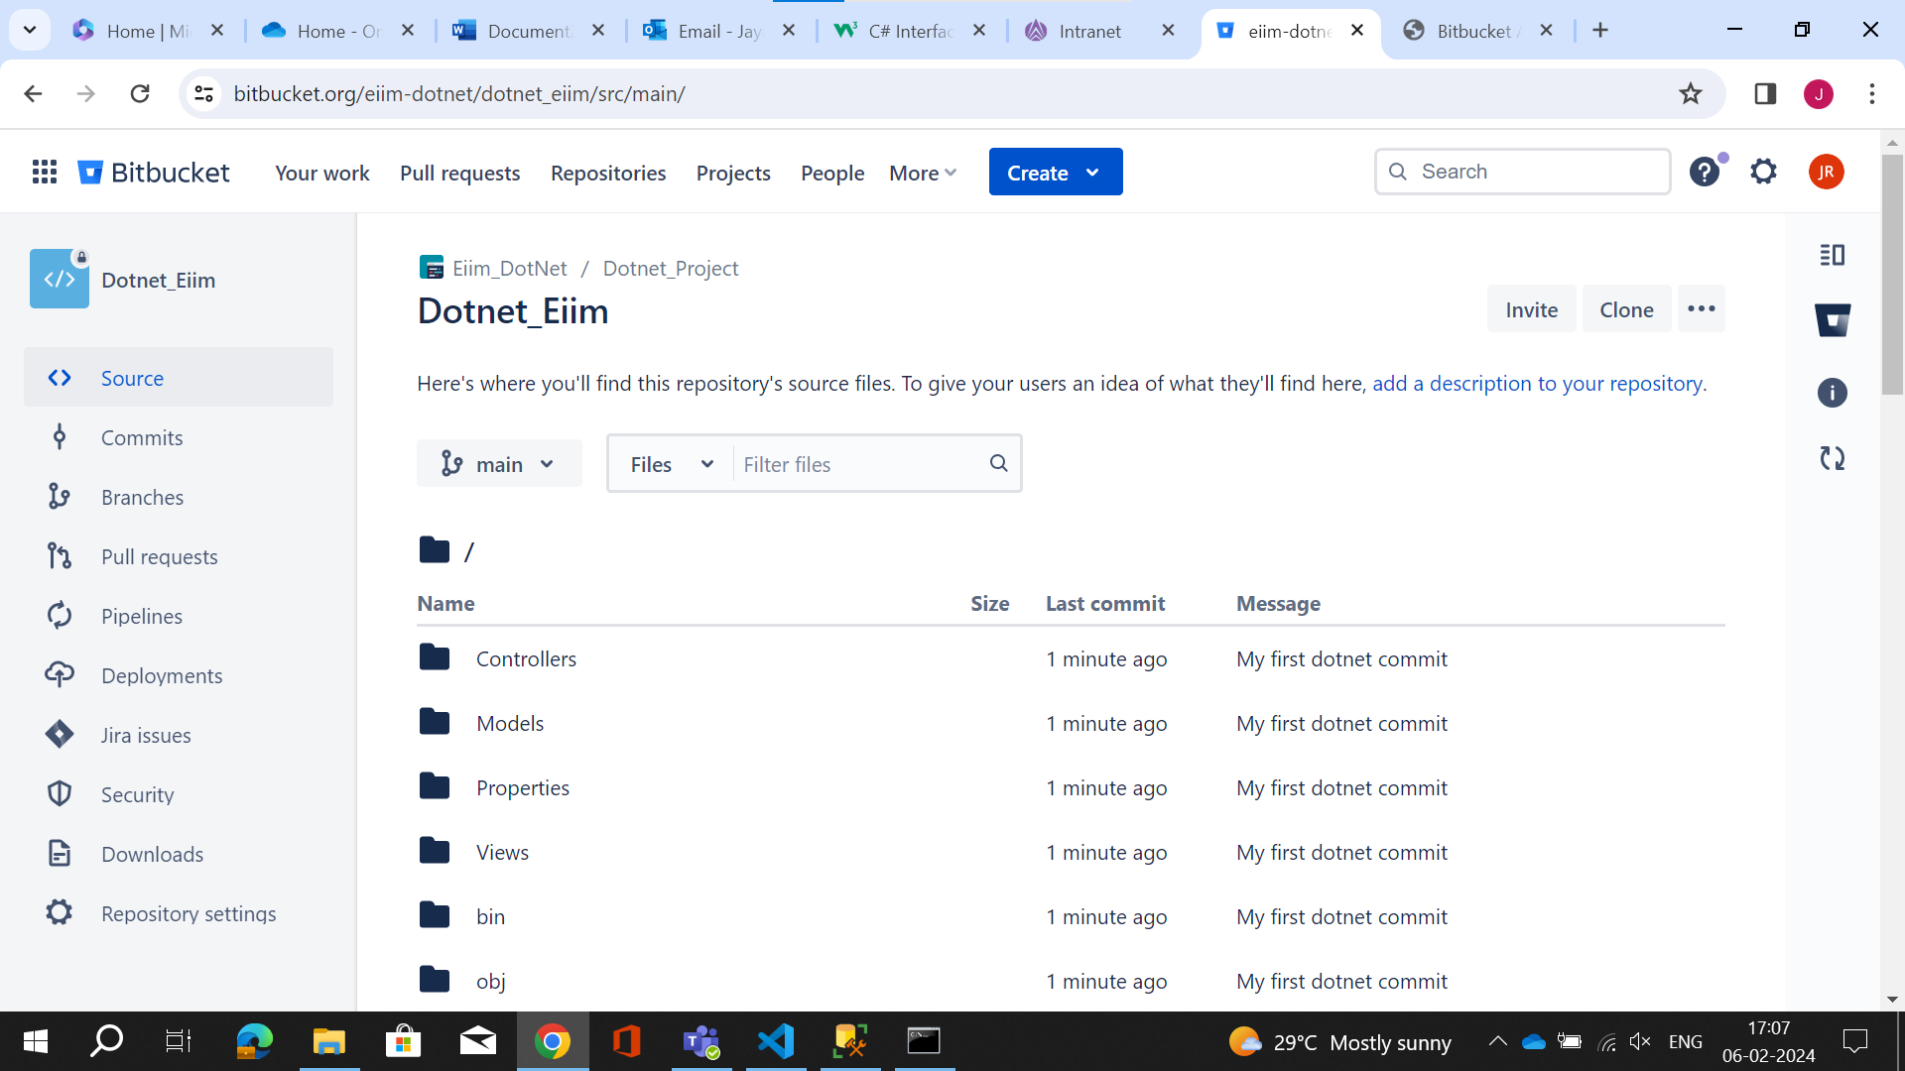

Now im going with azure repo for importing the bitbucket repo.

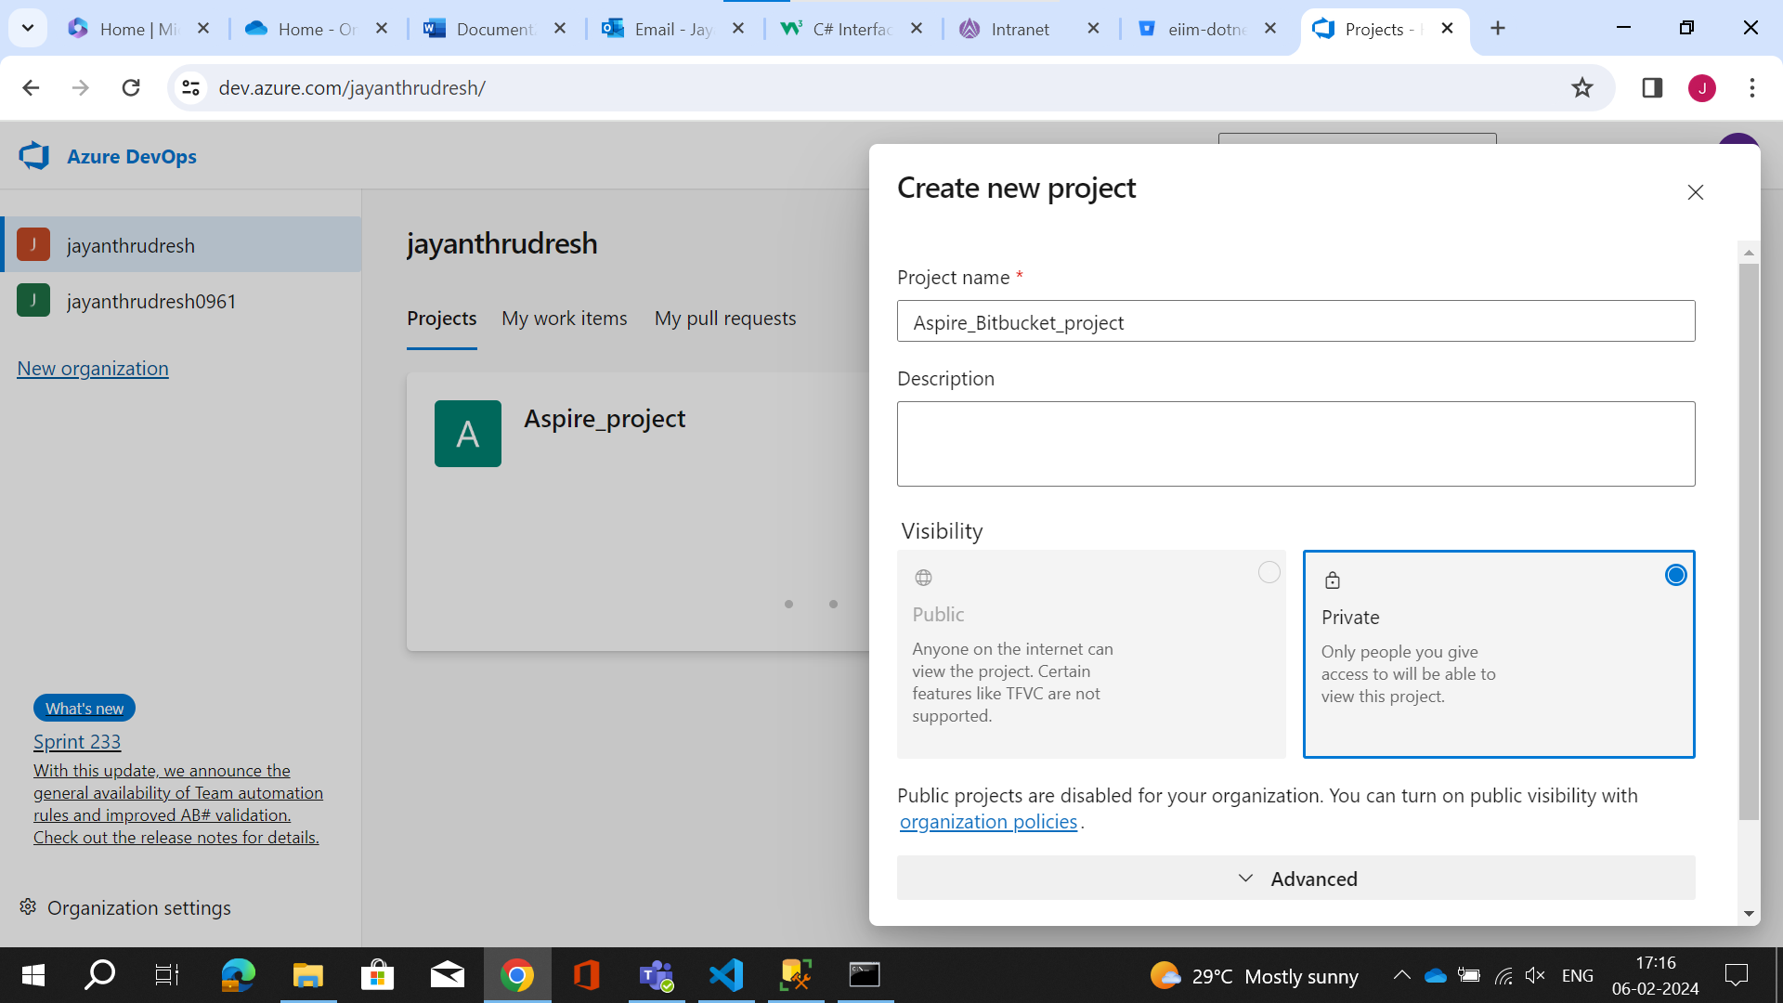

This is the import repo option i provide the link of bitbucket and import it.

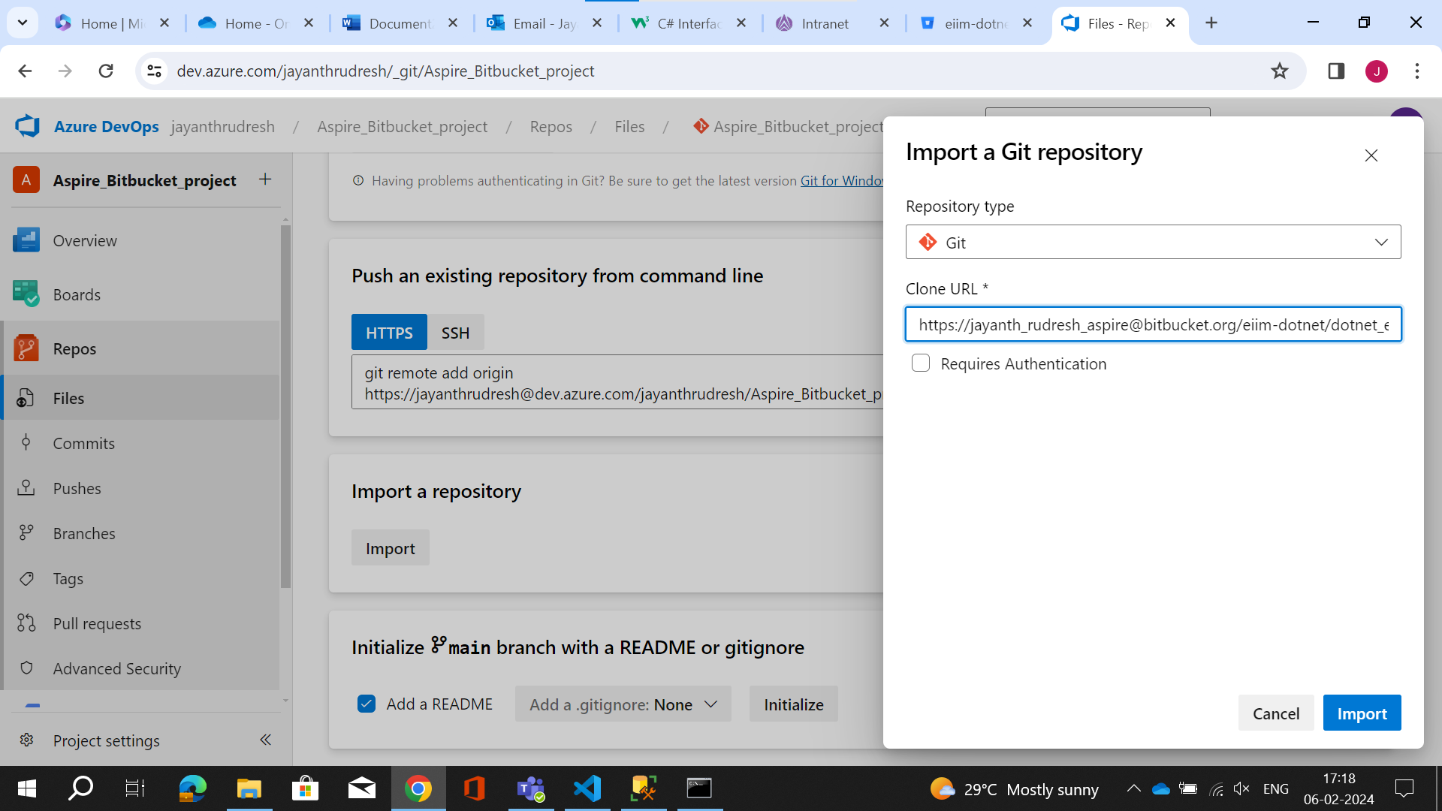

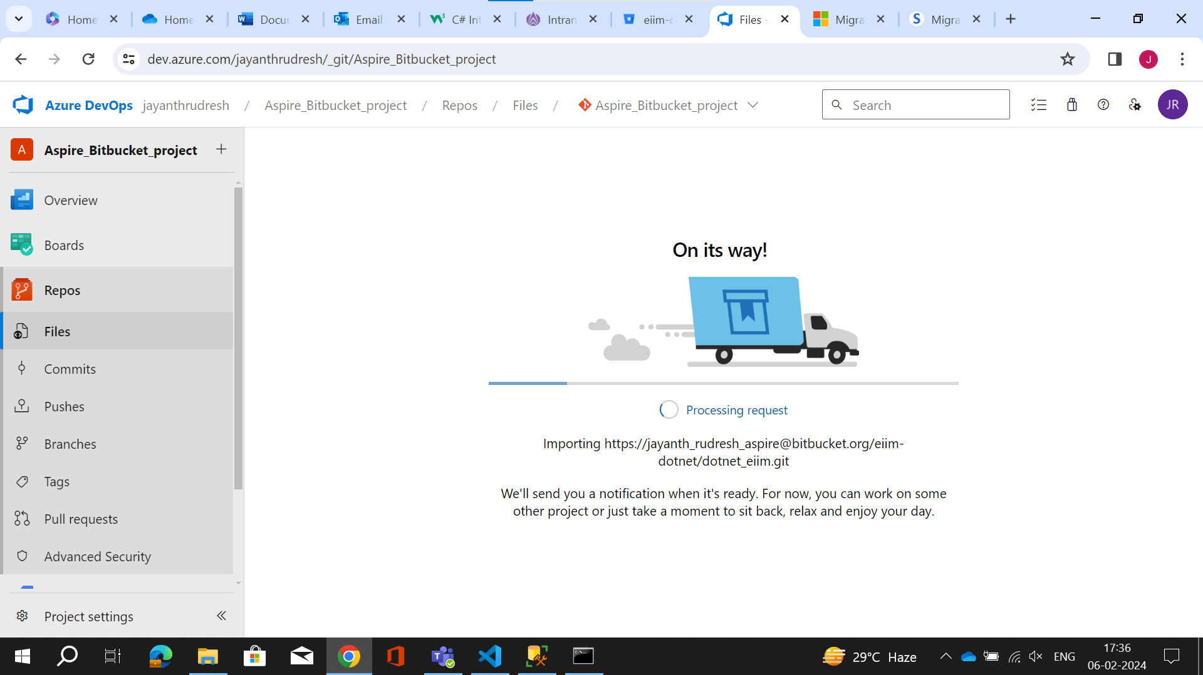

Here we can see i have imported my bitbucket repo.

